PROJECT 3 TOPOLOGY

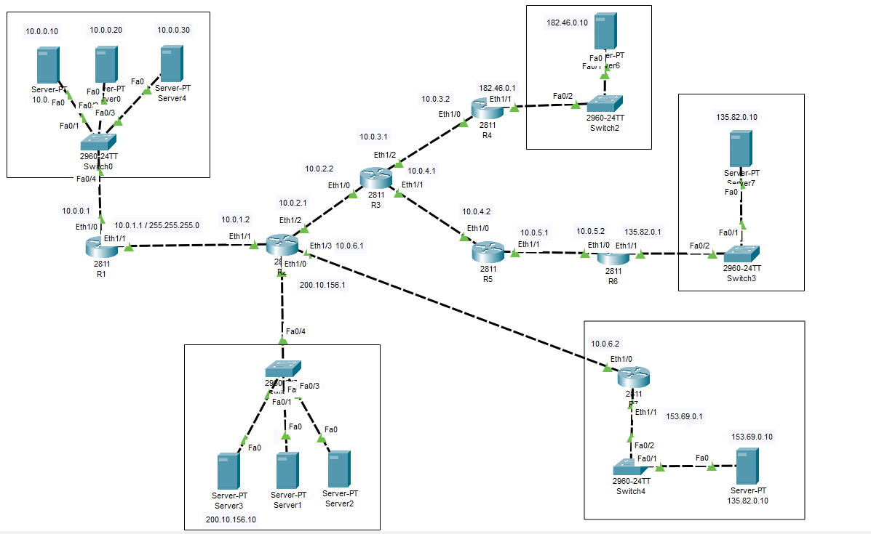

incorrect IP address assignment error in the router 1
interface Ethernet1/0
ip address 10.0.0.1 255.0.0.0

interface Ethernet1/1
ip address 10.0.1.1 255.0.0.0
% 10.0.0.0 overlaps with Ethernet1/0
Ethernet1/1: incorrect IP address assignment

This error is because of your subnet mask.

What was Configured:
Ethernet1/0 → 10.0.0.1 255.0.0.0
255.0.0.0 is /8, which means the entire 10.0.0.0 – 10.255.255.255 range is one network.
So when entered second interface 1/1 :
Ethernet1/1 → 10.0.1.1 255.0.0.0
the router sees both interfaces as belonging to the same network: 10.0.0.0/8.
That's why we get error as % 10.0.0.0 overlaps with Ethernet1/0

Correct configuration
If you want two different networks, use /24:
interface Ethernet1/0
ip address 10.0.0.1 255.255.255.0
no shutdown
exit

interface Ethernet1/1
ip address 10.0.1.1 255.255.255.0
no shutdown
exit

Now the networks are:
Interface | IP Address | Mask | Network
Ethernet1/0 | 10.0.0.1 | 255.255.255.0 (/24) | 10.0.0.0
Ethernet1/1 | 10.0.1.1 | 255.255.255.0 (/24) | 10.0.1.0
These are two separate networks, so the router will accept them.

Complete static-routing configuration for Router 1 to Router 7.

Make all server networks communicate with each other, example:
Server 0 (10.0.0.10) → Server 8 (153.69.0.10)

Default interface ip configuration
First, keep this addressing table to Configure:
Router | Interface | IP Address | Network | Connected to
R1 | Eth1/0 | 10.0.0.1/24 | 10.0.0.0/24 | Server LAN
R1 | Eth1/1 | 10.0.1.1/24 | 10.0.1.0/24 | R2
R2 | Eth1/2 | 10.0.1.2/24 | 10.0.1.0/24 | R1
R2 | Eth1/1 | 10.0.2.1/24 | 10.0.2.0/24 | R3
R2 | Eth1/3 | 10.0.6.1/24 | 10.0.6.0/24 | R7
R2 | Eth1/0 | 200.10.156.1/24 | 200.10.156.0/24 | Server LAN
R3 | Eth1/2 | 10.0.2.2/24 | 10.0.2.0/24 | R2
R3 | Eth1/0 | 10.0.3.1/24 | 10.0.3.0/24 | R4
R3 | Eth1/1 | 10.0.4.1/24 | 10.0.4.0/24 | R5
R4 | Eth1/1 | 10.0.3.2/24 | 10.0.3.0/24 | R3
R4 | Eth1/0 | 182.46.0.1/24 | 182.46.0.0/24 | Server LAN
R5 | Eth1/0 | 10.0.4.2/24 | 10.0.4.0/24 | R3
R5 | Eth1/1 | 10.0.5.1/24 | 10.0.5.0/24 | R6
R6 | Eth1/0 | 10.0.5.2/24 | 10.0.5.0/24 | R5
R6 | Eth1/1 | 135.82.0.1/24 | 135.82.0.0/24 | Server LAN
R7 | Eth1/0 | 10.0.6.2/24 | 10.0.6.0/24 | R2
R7 | Eth1/1 | 153.69.0.1/24 | 153.69.0.0/24 | Server LAN

Configure Router 1 static routes
directly connected routes:
10.0.0.0/24
10.0.1.0/24
Configure Router 1 static routes
ip route 10.0.2.0 255.255.255.0 10.0.1.2
ip route 10.0.3.0 255.255.255.0 10.0.1.2
ip route 10.0.4.0 255.255.255.0 10.0.1.2
ip route 10.0.5.0 255.255.255.0 10.0.1.2
ip route 10.0.6.0 255.255.255.0 10.0.1.2

ip route 182.46.0.0 255.255.255.0 10.0.1.2
ip route 135.82.0.0 255.255.255.0 10.0.1.2
ip route 153.69.0.0 255.255.255.0 10.0.1.2
ip route 200.10.156.0 255.255.255.0 10.0.1.2

Configure Router 2 static routes
directly connected routes:
10.0.1.0/24
10.0.2.0/24
10.0.6.0/24
200.10.156.0/24
Route to R1's LAN Next hop = R1 10.0.1.1
Routes toward R3 Next hop = R3 10.0.2.2
Route toward R7 Next hop = R7 10.0.6.2

Configure Router 2 static routes

R1 Server LAN
ip route 10.0.0.0 255.255.255.0 10.0.1.1

R4 side
ip route 10.0.3.0 255.255.255.0 10.0.2.2
ip route 182.46.0.0 255.255.255.0 10.0.2.2

R5/R6 side
ip route 10.0.4.0 255.255.255.0 10.0.2.2
ip route 10.0.5.0 255.255.255.0 10.0.2.2
ip route 135.82.0.0 255.255.255.0 10.0.2.2

R7 Server LAN
ip route 153.69.0.0 255.255.255.0 10.0.6.2

Configure Router 3 static routes
directly connected routes:
10.0.2.0/24
10.0.3.0/24
10.0.4.0/24
For R1/R2 side R2 = 10.0.2.1
For R4: R4 = 10.0.3.2
For R5: R5 = 10.0.4.2
Configure Router 3 static routes

! Toward R1/R2
ip route 10.0.0.0 255.255.255.0 10.0.2.1
ip route 10.0.1.0 255.255.255.0 10.0.2.1
ip route 10.0.6.0 255.255.255.0 10.0.2.1
ip route 200.10.156.0 255.255.255.0 10.0.2.1
ip route 153.69.0.0 255.255.255.0 10.0.2.1

! Toward R4
ip route 182.46.0.0 255.255.255.0 10.0.3.2

! Toward R5/R6
ip route 10.0.5.0 255.255.255.0 10.0.4.2
ip route 135.82.0.0 255.255.255.0 10.0.4.2

Configure Router 4 static routes
directly connected routes:
10.0.3.0/24
182.46.0.0/24
Everything else goes toward R3: R3 = 10.0.3.1
Configure Router 4 static routes
ip route 10.0.0.0 255.255.255.0 10.0.3.1
ip route 10.0.1.0 255.255.255.0 10.0.3.1
ip route 10.0.2.0 255.255.255.0 10.0.3.1
ip route 10.0.4.0 255.255.255.0 10.0.3.1
ip route 10.0.5.0 255.255.255.0 10.0.3.1
ip route 10.0.6.0 255.255.255.0 10.0.3.1

ip route 135.82.0.0 255.255.255.0 10.0.3.1
ip route 153.69.0.0 255.255.255.0 10.0.3.1
ip route 200.10.156.0 255.255.255.0 10.0.3.1

Configure Router 5 static routes
directly connected routes:
10.0.4.0/24
10.0.5.0/24
R3 = 10.0.4.1
R6 = 10.0.5.2
Configure Router 5 static routes

! Toward R3/R2/R1/R7
ip route 10.0.0.0 255.255.255.0 10.0.4.1
ip route 10.0.1.0 255.255.255.0 10.0.4.1
ip route 10.0.2.0 255.255.255.0 10.0.4.1
ip route 10.0.3.0 255.255.255.0 10.0.4.1
ip route 10.0.6.0 255.255.255.0 10.0.4.1

ip route 182.46.0.0 255.255.255.0 10.0.4.1
ip route 153.69.0.0 255.255.255.0 10.0.4.1
ip route 200.10.156.0 255.255.255.0 10.0.4.1

! Toward R6
ip route 135.82.0.0 255.255.255.0 10.0.5.2

Configure Router 6 static routes
directly connected routes:
10.0.5.0/24
135.82.0.0/24
Everything else goes to R5: R5 = 10.0.5.1
Configure Router 6 static routes

ip route 10.0.0.0 255.255.255.0 10.0.5.1
ip route 10.0.1.0 255.255.255.0 10.0.5.1
ip route 10.0.2.0 255.255.255.0 10.0.5.1
ip route 10.0.3.0 255.255.255.0 10.0.5.1
ip route 10.0.4.0 255.255.255.0 10.0.5.1
ip route 10.0.6.0 255.255.255.0 10.0.5.1

ip route 182.46.0.0 255.255.255.0 10.0.5.1
ip route 153.69.0.0 255.255.255.0 10.0.5.1
ip route 200.10.156.0 255.255.255.0 10.0.5.1

Configure Router 7 static routes
R7 directly knows:
10.0.6.0/24
153.69.0.0/24
Everything else goes to R2: R2 = 10.0.6.1
Configure Router 7 static routes

ip route 10.0.0.0 255.255.255.0 10.0.6.1
ip route 10.0.1.0 255.255.255.0 10.0.6.1
ip route 10.0.2.0 255.255.255.0 10.0.6.1
ip route 10.0.3.0 255.255.255.0 10.0.6.1
ip route 10.0.4.0 255.255.255.0 10.0.6.1
ip route 10.0.5.0 255.255.255.0 10.0.6.1

ip route 182.46.0.0 255.255.255.0 10.0.6.1
ip route 135.82.0.0 255.255.255.0 10.0.6.1
ip route 200.10.156.0 255.255.255.0 10.0.6.1

Configure the servers
Router 1 Server LAN
IP: 10.0.0.10
Mask: 255.255.255.0
Gateway: 10.0.0.1
Router 2 Server LAN
IP: 200.10.156.10
Mask: 255.255.255.0
Gateway: 200.10.156.1
Router 4 Server LAN
IP: 182.46.0.10
Mask: 255.255.255.0
Gateway: 182.46.0.1
Router 6 Server LAN
IP: 135.82.0.10
Mask: 255.255.255.0
Gateway: 135.82.0.1
Router 7 Server LAN
IP: 153.69.0.10
Mask: 255.255.255.0
Gateway: 153.69.0.1

Test step-by-step
Test 1 — R1 to R2
On R1:
ping 10.0.1.2

Test 2 — R2 to R3
On R2:
ping 10.0.2.2

Test 3 — R3 to R4
ping 10.0.3.2

Test 4 — R3 to R5
ping 10.0.4.2

Test 5 — R5 to R6
ping 10.0.5.2

Test 6 — R2 to R7
ping 10.0.6.2

Now test the servers
From Server 0: ping 10.0.0.1
First confirm its gateway.
Then: ping 10.0.1.2
Then: ping 10.0.2.2
Finally test the remote server: ping 153.69.0.10
You should get:Reply from 153.69.0.10: bytes=32 time<1ms TTL=...

Test the opposite direction
From Server 8:
ping 153.69.0.1
Then:
ping 10.0.0.10
If both directions work:
10.0.0.10 ←→ 153.69.0.10
your routing is working.

Configure static routes on both sides. A packet needs a route to go forward and a route to come back.

Result from 10.0.0.10 to All the branches

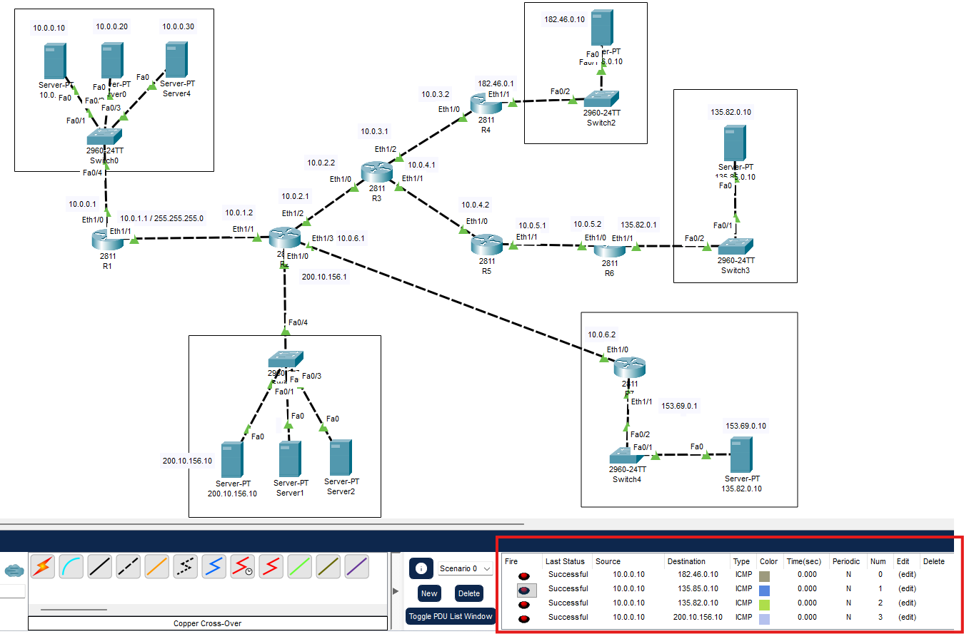

Result from All the branches to 10.0.0.10

